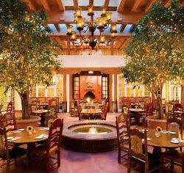

Welcome to Santa Fe, MN

“TIPS”

to assist you during your visit to Santa Fe

Deb Munsell, Rocky Mountain Regional Director

Gail Ferguson, South Central Regional Director
Deb and Gail will be available in the hotel lobby every day from 1200-1230 to assist you with any questions/concerns you may have. Please call us at any time during your visit.
Deb’s cell: (719)-600-7190
Gail’s cell: (702) 287-6933

High Altitude Note:
**Remember Santa Fe is located at high altitude of 7,199 feet above sea level so please continue to keep extra hydrated with water to prevent altitude sickness.
Amount of water: Water consumption is twice what you normally drink.
Altitude Sickness Symptoms: include headache, dizziness, nausea, fatigue, and shortness of breath. Alcohol may make it more difficult to acclimate to higher altitudes. However, alcohol may exacerbate some of the effects associated with altitude sickness or make it more difficult to acclimate to elevated conditions. (Note: more research is need.) That said, people might feel relatively more impaired because the symptoms of alcohol intoxication, such as dizziness, closely resemble the effects of altitude sickness.

Free transportation around town:
To get to the “Top of the Hill” Museums please take the public transportation bus located near the Plaza behind the Museum of Fine Arts, on Sheridan St. Look for the sign on the sidewalk that reads: “Santa Fe FREE shuttle pickup“
Times for bus: are approximately every 30 minutes.
https://www.santafenm.gov/santa_fe_pickup_shuttle
Go to www.takethetrails.com to download free Santa Fe pickup brochures with map locations and times.

Option to purchase “Cultural Pass” to visit many of the museums:
**If you wish to purchase the “Cultural Pass” its $30 and lets you into four museums in Santa Fe and two in Albuquerque for a discount price. Copy and click into your browser: https://www.newmexicoculture.org/visit/culturepass Or, you may pick and choose the museums you wish to explore on your own and pay individually. (Remember to show your military ID.)

Tips for walking around the museums located at Top of the Hill:
There are four museums up on the hill along with the Santa Fe Botanical Garden:
-Museum of International Folk Art is a “not to miss” and very special with thousands of little people in small villages that tell a story about us all. (Part of Cultural Pass)

-Museum of Indian Arts and Culture. Also, sponsoring an exhibition called “Clearly Indigenous” Native Visions Reimagined in Glass” which is incredible glass artwork...very pretty. (Part of Cultural Pass.)

-Wheelwright Museum of the American Indian. This museum houses many paintings of beautiful artwork and a large display of Indian Jewelry. (This museum is free to Veterans so just show your military ID here.) Don’t miss the Trading Post in the basement along with restrooms. In addition, there is a Docent available so please check out the website and call ahead to make a reservation if you wish an intimate tour guide of this museum.

-Museum of Spanish Colonial Art (Please check days open.)

-The Santa Fe Botanical Garden is also located at Top of the Hill. It’s open Sundays and Mondays and cost is $10/person.

-Don’t miss the Labyrinth at the Plaza located on the “Top of the Hill”...there is a surprise when u reach the center!

-There is a nice Grill/Cafe in the plaza area between the International Folk Art and Indian Culture Museums.

Tips for walking around the Historical Plaza downtown:
-There are many secret little gardens in and around the entire Santa Fe historical area. Keep your “eyes” looking for them and just pop in any number of them to discover...very special!

-Georgia O’Keeffe museum is very popular requires a reservation. (Due to pandemic, guided tours are on hold and hopeful they returning for our upcoming visit.)
**Reservations required, tickets can be purchased 30-days in advance. ***Website: https://www.okeeffemuseum.org/tickets-and-tours/

Georgia Totto O'Keeffe was an American artist. She was known for her paintings of enlarged flowers, New York skyscrapers, and New Mexico landscapes. O'Keeffe has been recognized as the "Mother of American modernism".

-New Mexico History Museum/Museum Palace of the Governors, which tells the stories that, made the American West-Native people and Spanish colonists.

-New Mexico Museum of Art: houses more then 20,000 works of American and European art.

Tips for walking the galleries on Canyon Road:
There are over 100 art galleries, boutiques, restaurants and “secret gardens” to explore along a ½mile road. Santa Fe is the one of the top three art capitals in the USA.

If you are hungry, Cafe Greco, known for its classic Greek Cuisine, located across from 225 Canyon Road is fantastic! Serving breakfast, lunch, and dinner. Ask for the owner Michael and he will sing you an opera song as well! (Let him know you are an Air Force nurse and receive discounts from his jewelry/clothing boutique as well.)

If you have a car: and want a truly authentic (Off-the-beaten-path) and desire a family friendly priced Mexican Food experience, Los Potrillos is truly outstanding!
*Closed on Wednesdays
Address:
1947 Cerrillos Rd.
Website: https://www.google.com/search?q=los+portillos&ie=UTF-8&oe=UTF-8&hl=en-us&client=safari

If you don’t have a car: and looking for something special within walking distance from our hotel and near the plaza, check out La Casa Sena and ask to sit in the outdoor courtyard, if the weather is nice, as indoor dining is also special. Highest recommendation is “make a reservation” as far in advance as you can.
Address: 125 E. Palace Ave
https://www.lacasasena.com
Website: https://www.google.com/search?q=sena+santa.fe.restirant&ie=UTF-8&oe=UTF-8&hl=en-us&client=safari

Touring the capital:
New Mexico became America's 47th state on Jan. 6, 1912, signed into statehood by Pres. William Howard Taft.

Not far from our hotel, and within walking distance you may choose to tour the State Capitol Building in Santa Fe, New Mexico. In fact, award-winning art is a main component of a capitol building tour. With nearly 600 artworks featured in public spaces in the capitol annex and on the capitol grounds, you will feel more like it’s touring an art museum than a typical marble and granite-style government building. Visit the New Mexico Capitol Art Collection website for more information on the art and the artists.

Self-guided Info: Self-guided tours are available 8am to 5pm Monday through Friday year-round.
Guided tours: For information about guided tours of the New Mexico State Capitol by appointment, call (505) 986-4589 during business hours Monday through Friday.
Website: https://www.roadtripsforfamilies.com/touring-the-state-capitol-building-in-santa-fe-new-mexico/

Book titles: you might want to read prior to your visit:
-Appetite for America by Steven Fried
-Blood and Thunder by Hampton Sides
-The West by Ken Burns
-109 East Palace by Jennet Conant (Robert Oppenheimer and the Secret City of Los Alamos)
-Short Nights of the Shadow Cather by Timothy Egan

Movie: The Harvey Girls with Judy Garland

Last, the LaFonda Hotel will be celebrating its Centennial Celebration 2022 so we will see how we can be apart of the celebration!

Wishing you safe travels
and
looking forward to a great time exploring this beautiful city with all of you!

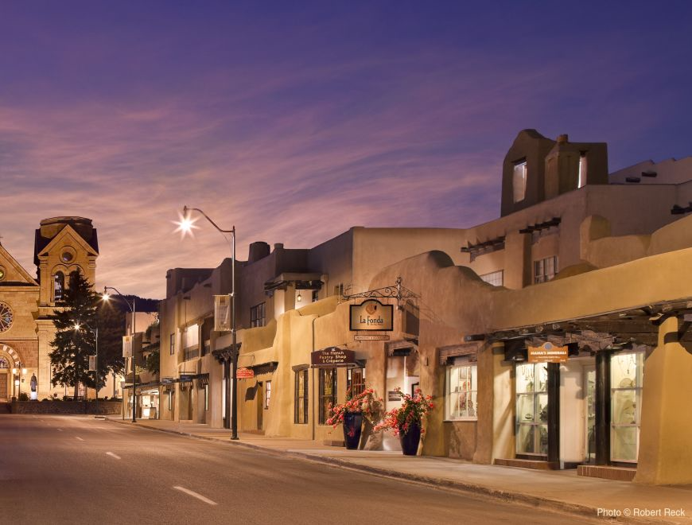

Santa Fe Visitors Guide 2021 (Digital Edition) by Visit Santa Fe: https://issuu.com/visitsantafe/docs/santa_fe_vg_2021_digital_book/1?ff&backgroundColorFullscreen=%23F0F3F4

